Release Note (Qbuzz_release0.0.1_EAM11.7-Qbuzz-New tab on WSJOBO .zip)
EAM11.7-Qbuzz
Title:  EAM11.7-Qbuzz | Date Issued  21st-Sept-2022

General comments
This implementation is based on INFOR EAM 11.7

List of observations addressed in this patch/fixes/modifications
S. No. | Description of Observation | Files
1. | EAM11.7- Qbuzz-New Tab on WSJOBO | Db scripts  - SPC-254.sql  EF  - qbz_external_wsjobo.ef.txt

Pre-Installation instructions
In an effort to ensure that your INFOR EAM system continues to operate with maximum efficiency and minimal problems, Infor strongly recommends that you:
- Apply this fix to a test environment and perform your own user acceptance testing before applying this customization to your production environment.
- Db scripts can only be run when user defined screen has been generated.

Configuration Instructions
- Create Job type: Administrator -- > Setup -- > System Codes
Setup: Types
For Entity: JBTP
User Code | System Code | Description
STO | BR | Malfunction
SCH | * | Damage

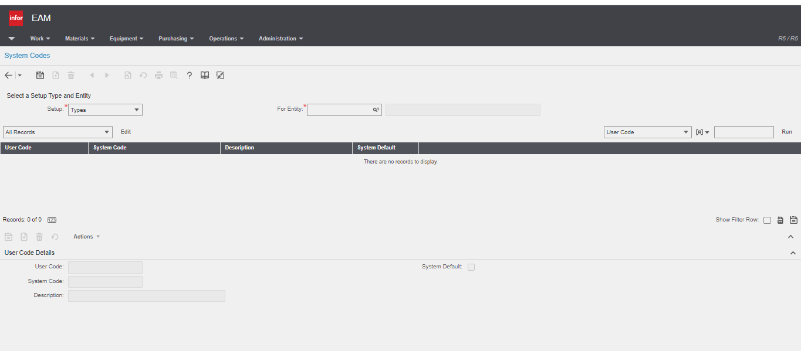

2. Screen Setup: Administrator -- > Screen Configuration -- > Screen Setup
Screen: WSJOBO
Filter type: Checked

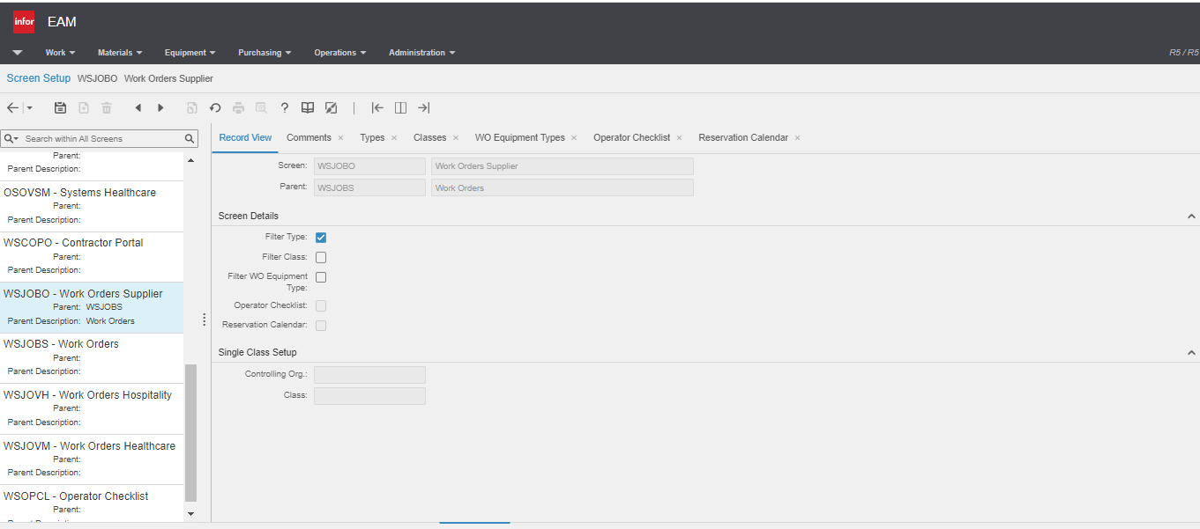

Navigate to ‘Types’ tab: Select type:- Malfunction and Damage
Click on Save

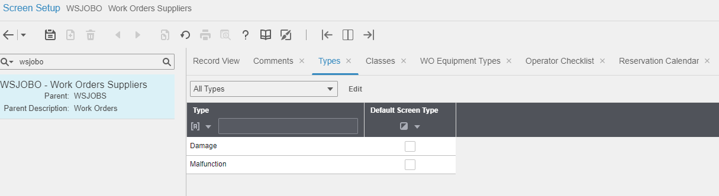

3. Create Classes for EVNT: Administrator -- > Setup -- > Classes.

Entity | Class | Description
EVNT | BU | BUSSEN
EVNT | LA | Laad Infrastructuur
EVNT | VF | Vastgoed en Facilitair

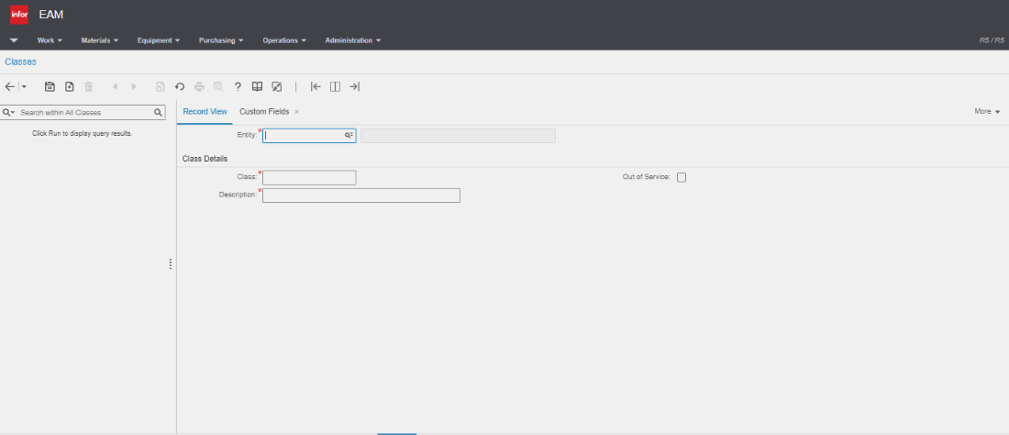

- Create Status for EVNT: Administrator -- > Setup -- > System Codes
Setup: Statuses
For Entity: EVST
User Code | System Code | Description | Beschrijving
W | R | To be processed | In behandeling te nemen
IBL | R | Pending Vendor | in behandeling leverancier
AL | R | Rejected by Vendor | Afgewezen door leverancier
IBQ | R | Assigned to Qbuzz Employee | In behandeling Qbuzz medewerker
OP | R | Reschedule | Opnieuw te plannen
PA | R | Paused | Gepauzeerd
TC | R | Technically Complete | Technisch gereed
TCS | R | Technically Complete Supplier | Technisch gereed leverancier
AG | R | Administratively Ready | Administratief gereed
IC | R | In Control | In controle
TF | R | To be Invoiced | Te Factureren
DI | R | Dispute | Dispuut
C | C | Completed | Voltooid
CA | R | Checked, agreed | Gecontroleerd Akkoord
WM | R | Waiting for Material | Wacht op material
EVO | R | Include in next planned maintenance | Eerst volgend onderhoud

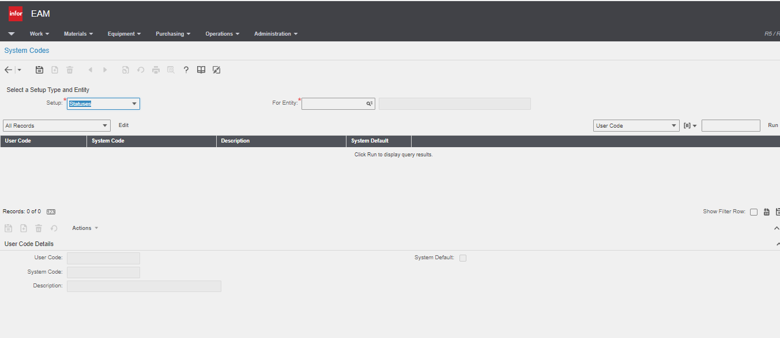

6. Create User Defined Screen Tab: Administrator -- > Screen Configuration -- > User defined screens

Screen Name | WUJOBO
Description | Supplier Book Hours and Materials
Table name | WOSUPP
Tab checkbox | Checked
Parent Screen | WSJOBO
Save the record
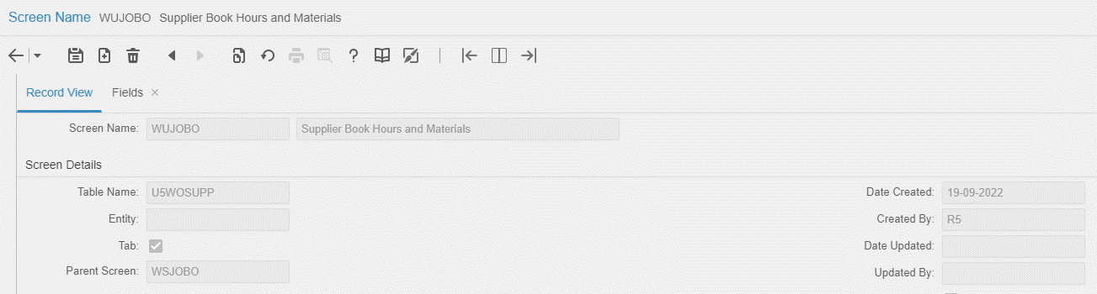

Navigate to Fields Tab
Please refer attached excel file for fields

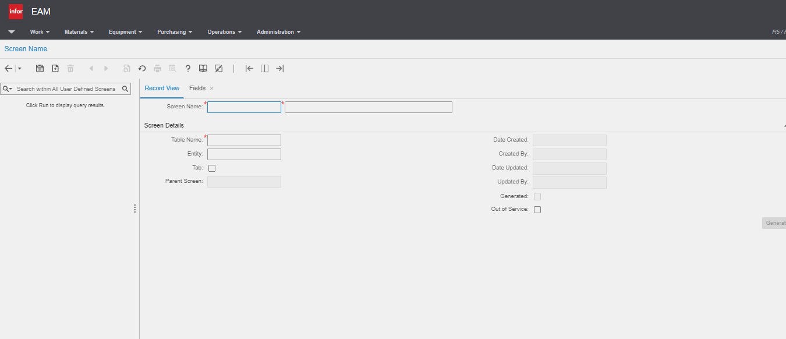

- Extensible Framework: Administrator Security Extensible Framework
Name: external_wsjobo
Screen: WSJOBO

8. User Defined Fields:

Screen Name | Tab Name | User Defined Fields | Fields Name | Lookup
WSJOBO | Record View | Evt_udfchar19 | Supplier | Entity- COMP
WSJOBO | Record View | Evt_udfchar22 | Reason for rejection
OSOBJA | Record View | Obj_udfchar17 | Supplier
WSJOBO | Record View | Evt_udfchkbox02 | Agree
WSJOBO | Activity | Act_udfchkbox03 | Warranty
SSSUPP | Record View | Com_udfchkbox01 | Contract Damage
SSSUPP | Record View | Com_udfchkbox02 | Monthly Invoice
WSTRAD | Rates | Trd_udfchar01 | Supplier | Entity- COMP
WSJOBO | Activity | Act_udfchar01 | Supplier

9. Please make sure below User Groups exists in EAM:
User Group: Vloot-Man
Supplier

10. User Group has permission for Tabs:

User Group | Tabs
Vloot-Man | Record View,  Comments,  Activities,  Book Labor,  Closing,  Parts,  Documents,  Supplier Book Hours and Materials.
Supplier | Record View,  Comments,  Activities,  Closing,  Documents,  Supplier Book Hours and Materials.

11. Please make sure trade rates for supplier should exist

Note: → If there is any error then please contact MCT.

Contents List
The release is contained in compressed file, which contains the following files:

- Db scripts: SPC-254.sql

- EF: qbz_external_wsjobo.ef.txt

- Release Note: Qbuzz_release0.0.1_EAM11.7-Qbuzz-New tab on WSJOBO

